## Reports Menu/HIPAA/HIPAA Records Request:

Request:

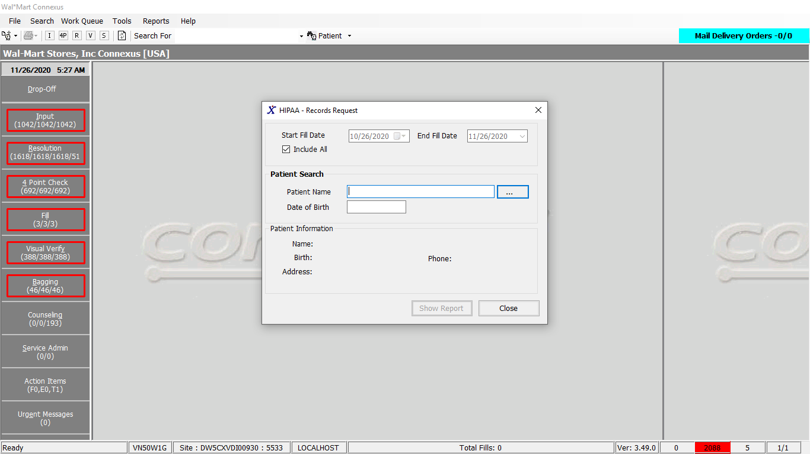

Response:

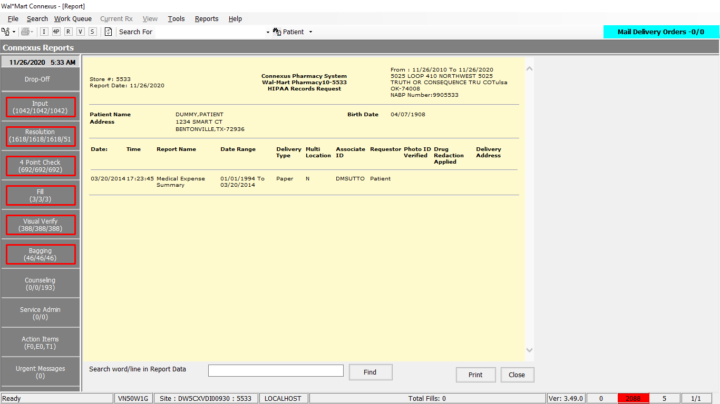

Query:

Friend Const HIPAAEPHIRecordsReport As String = "SELECT hi.disclosure_ts,hi.request_type_code, hi.request_start_ts,hi.request_end_ts, " & _

"hi.create_userid,ps.phm_signature_id , ephi.rqst_format_type_code, ephi.email_address_id , " & _

"ephi.multi_location_ind, rt.relationship_desc,ephi.cust_id_valdt_ind, ephi.drug_redaction_ind " & _

"FROM hipaa_info_request hi, Hipaa_rqst_patient hrp,OUTER phm_signature ps , hipaa_ephi_request ephi ,relationship_text rt " & _

"WHERE hrp.patient_id = ? " & _

"AND hrp.hipaa_info_rqst_id=hi.hipaa_info_rqst_id " & _

"AND hi.hipaa_info_rqst_id=ephi.hipaa_info_rqst_id " & _

"AND ps.phm_signature_id = hi.phm_signature_id " & _

"AND hi.relationship_code=rt.relationship_code " & _

"AND hi.requestor_type_cd= ? " & _

"AND hi.request_type_code IN (?,?) "

Friend Const GetHIPAAAccountDisclosureSelect1 As String = "SELECT patient_id, last_name, first_name, middle_name, gender_code, birth_date, pri_prescriber_id, snap_cap_rqst_date, patient_label_name, pref_language_code, relt_patient_id, relt_last_name, relt_first_name, relt_middle_name, address_line_1, address_line_2, city_name, state_prov_code, postal_code, country_code, ssn, drivers_license, dl_state_code, HomePhone, WorkPhone, Email,comment_text, alt_packaging, ar_account, presc_first_name, presc_middle_name, presc_last_name, pri_clinic_id, charge_freq_code, mail_out_freq_code, patient_DAW, print_HL, dflt_addr_type_cd, hipaa_status_code FROM v_Patient WHERE patient_id = ?"

DAL

Public Function GetBasicPatientInfoForHipaa(ByVal siteId As Integer,

ByVal patientId As Integer) As PatGeneralInfoBE Implements IHIPAADAL.GetBasicPatientInfoForHipaa

Dim paramList As New List(Of DbParameter)

paramList.AddParameter(DbType.Int32, patientId)

Dim patGenInfoBE As PatGeneralInfoBE = Nothing

Using dr As IDataReader = ExecuteReader(DatabaseEnum.rx21c, siteId, HipaaQueries.GetHIPAAAccountDisclosureSelect1, paramList)

If dr.Read Then

patGenInfoBE = New PatGeneralInfoBE

Dim personalInfo As New PersonalInfoBE

Dim contactInfo As New ContactInfoBE

Dim primaryPrescInfo As New PrimaryPrescInfoBE

Dim miscPersonalInfo As New MiscPersonalInfoBE

Dim otherInfo As New OtherInfoBE

Dim hipaaInfo As New Entities.Patient.HipaaInfoBE

Dim relatedPatientInfo As New RelatedPatientBE

personalInfo.LastName = dr.GetValueOrDefault(Of String)("last_name").SafeTrim()

personalInfo.FirstName = dr.GetValueOrDefault(Of String)("first_name").SafeTrim()

personalInfo.MiddleName = dr.GetValueOrDefault(Of String)("mIddle_name").SafeTrim()

personalInfo.Gender = dr.GetValueOrDefault(Of String)("gender_code").SafeTrim()

personalInfo.Dob = dr.GetValueOrDefault(Of DateTime)("birth_date")

primaryPrescInfo.PrescriberId = dr.GetValueOrDefault(Of Int32)("pri_prescriber_Id")

miscPersonalInfo.SnapCapRequestDate = dr.GetValueOrDefault(Of DateTime)("snap_cap_rqst_date")

patGenInfoBE.PatientLabelName = dr.GetValueOrDefault(Of String)("patient_label_name").SafeTrim()

personalInfo.Language = dr.GetValueOrDefault(Of String)("pref_language_code").SafeTrim()

relatedPatientInfo.PatientId = dr.GetValueOrDefault(Of Int32)("relt_patient_Id")

relatedPatientInfo.LastName = dr.GetValueOrDefault(Of String)("relt_last_name").SafeTrim()

relatedPatientInfo.FirstName = dr.GetValueOrDefault(Of String)("relt_first_name").SafeTrim()

relatedPatientInfo.MiddleName = dr.GetValueOrDefault(Of String)("relt_mIddle_name").SafeTrim()

contactInfo.AddressLine1 = dr.GetValueOrDefault(Of String)("address_line_1").SafeTrim()

contactInfo.AddressLine2 = dr.GetValueOrDefault(Of String)("address_line_2").SafeTrim()

contactInfo.City = dr.GetValueOrDefault(Of String)("city_name").SafeTrim()

contactInfo.State = dr.GetValueOrDefault(Of String)("state_prov_code").SafeTrim()

contactInfo.ZipCode = dr.GetValueOrDefault(Of String)("postal_code").SafeTrim()

contactInfo.Country = dr.GetValueOrDefault(Of String)("country_code").SafeTrim()

miscPersonalInfo.Ssn = dr.GetValueOrDefault(Of String)("ssn").SafeTrim()

miscPersonalInfo.DriversLicense = dr.GetValueOrDefault(Of String)("drivers_license").SafeTrim()

miscPersonalInfo.DriversLicenseState = dr.GetValueOrDefault(Of Int32)("dl_state_code")

contactInfo.HomePhone = dr.GetValueOrDefault(Of String)("HomePhone").SafeTrim()

contactInfo.WorkPhone = dr.GetValueOrDefault(Of String)("WorkPhone").SafeTrim()

contactInfo.EmailAddress = dr.GetValueOrDefault(Of String)("Email").SafeTrim()

otherInfo.CommentText = dr.GetValueOrDefault(Of String)("comment_text").SafeTrim()

patGenInfoBE.AltPackaging = dr.GetValueOrDefault(Of String)("alt_packaging").SafeTrim()

patGenInfoBE.ARAccount = dr.GetValueOrDefault(Of String)("ar_account").SafeTrim()

primaryPrescInfo.FirstName = dr.GetValueOrDefault(Of String)("presc_first_name").SafeTrim()

primaryPrescInfo.MiddleName = dr.GetValueOrDefault(Of String)("presc_mIddle_name").SafeTrim()

primaryPrescInfo.LastName = dr.GetValueOrDefault(Of String)("presc_last_name").SafeTrim()

patGenInfoBE.ClinicId = dr.GetValueOrDefault(Of Int32)("pri_clinic_Id")

otherInfo.ChargeCode = dr.GetValueOrDefault(Of Int16)("charge_freq_code")

otherInfo.MailOutCode = dr.GetValueOrDefault(Of Int16)("mail_out_freq_code")

patGenInfoBE.Daw = dr.GetValueOrDefault(Of String)("patient_DAW").SafeTrim()

patGenInfoBE.PrintHL = dr.GetValueOrDefault(Of String)("print_HL").SafeTrim()

patGenInfoBE.DefaultAddressType = dr.GetValueOrDefault(Of Int16)("dflt_addr_type_cd")

hipaaInfo.HipaaStatusCode = dr.GetValueOrDefault(Of Int16)("hipaa_status_code")

personalInfo.ContactInformation = contactInfo

patGenInfoBE.PrimaryPrescriberInformation = primaryPrescInfo

patGenInfoBE.PersonalInfo = personalInfo

patGenInfoBE.RelatedPatient = relatedPatientInfo

patGenInfoBE.OtherInformation = otherInfo

patGenInfoBE.MiscPersonalInformation = miscPersonalInfo

patGenInfoBE.HipaaInformation = hipaaInfo

End If

End Using

Return patGenInfoBE

End Function

-------------------------------------------------------------------

DAL:

Public Function GetHipaaRecords(ByVal siteId As Integer, ByVal patientId As Integer,

ByVal startDate As Date, ByVal endDate As Date) _

As HipaaRecordsInfoBE Implements IHIPAADAL.GetHipaaRecords

Using (New Tracer(ConnexusCommonConstants.ConnexusTracer))

Dim patientGeneralInfo As PatGeneralInfoBE = Nothing

patientGeneralInfo = GetBasicPatientInfoForHipaa(siteId, patientId)

Dim querySQL As New StringBuilder

querySQL.Append(HipaaQueries.HIPAAEPHIRecordsReport)

Dim paramList As New List(Of DbParameter)

paramList.AddParameter(DbType.Int32, patientId, "PatientId")

paramList.AddParameter(DbType.Int32, ServicesCommonConstants.HIPAAPatientRequest, "RequestorType")

paramList.AddParameter(DbType.Int32, HipaaReportTypes.MedExp, "RequestTypeCodeMES")

paramList.AddParameter(DbType.Int32, HipaaReportTypes.DesRcrd, "RequestTypeCodeDRS")

'Conditional Checking of startDate with DateTime.MinValue i.e. 01/01/0001 to ensure that the startDate field is selected in UI.

If Not startDate = DateTime.MinValue Then

querySQL.Append("AND hi.disclosure_ts >= ? AND hi.request_end_ts <= ?")

paramList.AddParameter(DbType.DateTime, startDate, "DisclosureStartDate")

paramList.AddParameter(DbType.DateTime, endDate, "DisclosureEndDate")

End If

Dim patHipaaRecordsInfoList As New List(Of PatHIPAARecordsBE)

Using dr As IDataReader = ExecuteReader(DatabaseEnum.rx21c, siteId, querySQL.ToString(), paramList)

Dim patHipaaRecordsInfo As PatHIPAARecordsBE = Nothing

While dr.Read

patHipaaRecordsInfo = New PatHIPAARecordsBE

patHipaaRecordsInfo.CreatedUserId = dr.GetValueOrDefault(Of String)("create_userId").SafeTrim()

patHipaaRecordsInfo.RequestTs = dr.GetValueOrDefault(Of DateTime)("disclosure_ts")

patHipaaRecordsInfo.RequestTypeCode = dr.GetValueOrDefault(Of Int16)("request_type_code")

patHipaaRecordsInfo.FromDate = dr.GetValueOrDefault(Of DateTime)("request_start_ts")

patHipaaRecordsInfo.ToDate = dr.GetValueOrDefault(Of DateTime)("request_end_ts")

patHipaaRecordsInfo.ComplaintSignatureId = dr.GetValueOrDefault(Of Int32)("phm_signature_id")

patHipaaRecordsInfo.RequestFormatType = dr.GetValueOrDefault(Of Int16)("rqst_format_type_code")

patHipaaRecordsInfo.EmailAddress = dr.GetValueOrDefault(Of String)("email_address_id").SafeTrim()

patHipaaRecordsInfo.RelationshipDesc = dr.GetValueOrDefault(Of String)("relationship_desc").SafeTrim()

patHipaaRecordsInfo.MultiLocationInd = dr.GetValueOrDefault(Of String)("multi_location_ind").SafeTrim()

'HIPAA Personal Representatives Phase 2 project changes - Start

'Fetch photo ID verified value

patHipaaRecordsInfo.PhotoIDVerifiedInd = dr.GetValueOrDefault(Of String)("cust_id_valdt_ind").SafeTrim()

'HIPAA Personal Representatives Phase 2 project changes - Start

'Drug redaction indicator is fetched from the DB

patHipaaRecordsInfo.DrugRedactionInd = dr.GetValueOrDefault(Of String)("drug_redaction_ind").SafeTrim()

patHipaaRecordsInfoList.Add(patHipaaRecordsInfo)

End While

End Using

Dim hipaaRecordsInfo As HipaaRecordsInfoBE = Nothing

If Not patientGeneralInfo Is Nothing Or Not patHipaaRecordsInfoList.Count = 0 Then

hipaaRecordsInfo = New HipaaRecordsInfoBE

hipaaRecordsInfo.PatientInfo = patientGeneralInfo

hipaaRecordsInfo.FromDate = startDate

hipaaRecordsInfo.ToDate = endDate

If Not patHipaaRecordsInfoList.Count = 0 Then

hipaaRecordsInfo.PatientHipaaRecordsInfo = patHipaaRecordsInfoList

End If

End If

Return hipaaRecordsInfo

End Using

End Function